USER REQUIREMENTS

The Bidder should provide the following in the specified order in Section 4 of the proposal/bid document.

Provide detail information of the proposed solution as per document enclosed. Please note that marking should be carried out in the following manner; The Remarks column should be used to explain or provide detail information.

DESCRIPTION | REMARKS
Rating - 5 | If the User requirement is met 100% as defined in the RFP without any work around method.
Rating - 4 | If the User requirement is met 75% as defined in the RFP without any work around method. Define the number of hours required for the modification and cost in US$ in the Remarks column, in order to provide 100% functionality as defined.
Rating - 3 | If the User requirement is met 50% as defined in the RFP without any work around method. Define the number of hours required for the modification and cost in US$ in the Remarks column, in order to provide 100% functionality as defined.
Rating - 2 | If the User requirement is met 25% as defined in the RFP without any work around method. Define the number of hours required for the modification and cost in US$ in the Remarks column, in order to provide 100% functionality as defined.
Rating - 1 | If the User requirement is met as a Work around method defined in the RFP. Define the number of hours required for the modification and cost in US$ in the Remarks column, in order to provide 100% functionality as defined.
Rating - 0 | If the User requirement is not met as a defined in the RFP and modifications are required. Define the number of hours required for the modification and costs in US$ in the Remarks column.

The NBL rating is as follows:
1 = critical; 2 = essential; 3 = nice to have

TRADE FINANCE
Ref | User Requirements | NBL Priority | Bidder’s Rating | Bidder’s Remarks
 | System should be able to process transactions at HO/ branch level or Vise versa (Multi Branch Access) with Branch/Department codes for monitoring event of the transaction. | 1 | 5 | Supported by T24.
 | System should have multiple accesses for inquiry/ validating transactions and window based to work in more than two menus/options to access at the same time (multiple tasks not dependent on each other). | 1 | 5 | Supported by T24.
 | All correspondences, whether produced automatically or manually must be verified before final release as default (exception with Bill schedule/Special products). | 1 | 5 | T24 allows setting of different number of authorizers for this purpose. Accepted values are 0, 1 and 2.  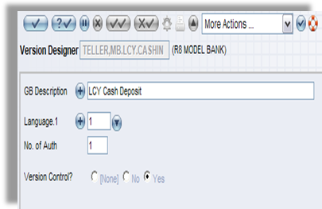  Figure 1. Number of authorizer
 | All public holidays and International holidays input to the system should be applicable to all products | 1 | 5 | Supported. T24 comes with the ability to setup different holiday tables for different countries and/or regions within a country for each year.  The processing of transactions will take into account of the pre-defined holidays.
 | Other delivery channels/system such as SWIFT, Electronic Banking, email, Scanner, fax server connectivity, e-commerce (Bolero.net) etc for integration with the main system, also for new products introduced. | 1 | 5 | Supported by T24. T24 provides an interface mechanism to permit linking of T24 to external systems. The mechanism is called Open Financial Service (OFS). Interfaces can be built between relevant systems of Bank and T24 for Accounting and other purposes. OFS is an interface that allows transactions and queries requests to be processed by T24. Various connectivity options are supported for communicating with OFS. OFS is the single point of entry to T24. Every single interaction with T24 is driven through OFS.  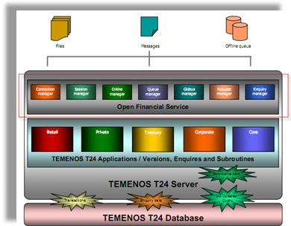  Figure 2. OFS mechanism
 | Back value/Post Valuation of transaction should be possible for collecting interest based on values set at organization level. If it exceeds the specified days or any no. of days, ability to post the transaction with authoriser’s approval and auto generate an exception report for Trade transactions. | 1 | 5 | Supported by T24.  Back value-date and future value date can be enter in the value date field, system will recognize whether it is back value, current or future value
 | Interest/Fee structure to be centralized at Risk Management and Control Department which controls all customer related fees/charges. (Fee on fee, Standard rates etc.) | 1 | 5 | Supported by T24.
 | Trade finance products to use system rates updated by Treasury (cross rates & USD/Rupee rate) and default them in the input screens.  Forward exchange contracts to be linked to all products. System should accept cross rate and not both exchange rates against local currencies only. | 1 | 5 | Supported by T24.  In the input screens, the system will get the rate that is updated by Treasury department as default value.
 | Option to print original & duplicate advices & Tracers (Bill Finance due/Collection Due/acceptance due) at  Branch/HO level. Re-printed advices/LCs should be logged with User ID. | 1 | 5 | T24 has a module called Delivery module which handles the formatting and auto generation of different types of advices. The advice can be configured as per the bank’s requirements.  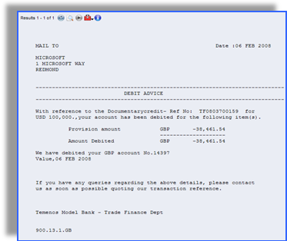  Figure 3. Customer Advice Sample (Auto Generated)
 | Daily exception report indicating Utilisation of facility over and above the limit | 1 | 5 | Supported by similar standard T24 report or enquiry.
 | Update Treasury position when a transaction is entered, marked pending authorisation. Dealers to input Exchange rate in the system and send back to Trade. |  | 5 | Supported by T24.
 | Automated Treasury Reporting to be Daily or at request. All transactionss. With Exchange rate and Interest rate should get printed with the fields – transactions ref, User id, Curr, Amount, value date, nostro a/c, and Exchange rate/Interest rate & tenor. | 1 | 5 | T24 has similar enquiries/reports. We are assuming that the format of these enquiries and reports meet the requirements of NDB Bank. If not, then NDB Bank can use T24 Enquiry and Report designer tools to modify them.  In addition, T24 Enquiry designer includes a wizard function to guide a user to design simple enquiries.  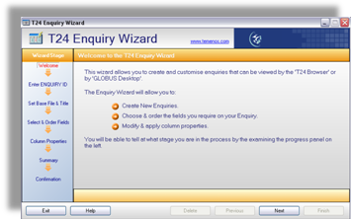  Figure 4. T24 Enquiry Wizard to guide users in designing enquiries
 | Automatic generation of Single Borrower Limit (SBL) entries: Any excess over Single Borrower Limit, System to generate entries automatically to default accounts  To clients with large facilities over the SBL. SBL can be changed time to time. | 1 | 5 | Supported by T24. System will automatically generate SBL and allow clients to change time to time.  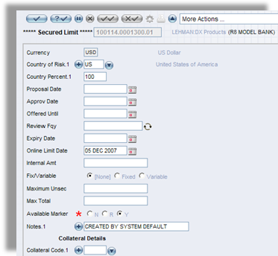  Figure 5. Limit Created By System Default
 | Commission payable on average balance of the SBL account to be AUTO settled monthly on a pro-rata basis. | 1 | 5 | Supported by T24 Account commission and charges functionality.
 | System to update Bi-lateral Key Exchange arrangement in SWIFT daily in order to give a warning message at the time of opening a L/C or generating an authenticated message. All Swift messages from system should be transmitted to SWIFT and automatically. (Straight Through Processing) | 1 | 4 | This is supported in T24 through Delivery Module with some configuration set-up.
 | Swift standard template should be available in the system to select from any products to create a message | 1 | 5 | These are handled by T24 Delivery module. T24 Delivery module supports all standard SWIFT messages.  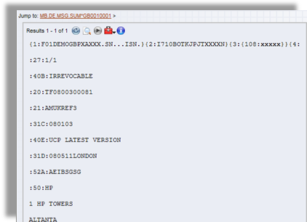  Figure 6. SWIFT Message
 | Standard clauses for Clean/Export bills and Import bills schedule should be available. | 1 | 5 | Supported by T24
 | Income distribution between Branches & Head Office: Any agreement with the branch for sharing income should be simplified by debiting Client account and crediting HO income & Branch income payable account on earning the income according to pre entered system values. | 1 | 5 | Supported by T24
 | To have an option to see all the unfinished/unapproved/Exceptional transactions end of the day. | 1 | 5 | Supported by T24
 | When currency code is used settlement Nostro account to pick automatically. (in multiple Nostro accounts user to select the applicable one) | 1 | 5 | Supported by T24
 | All products should have default debit/credit account per customer, however if additional accounts are available, System to prompt with other available numbers. Any change to default account should be highlighted to Authorizer. | 1 | 5 | Supported by T24.

